The Colosseum:

The Colosseum, an iconic symbol of ancient Rome, is an architectural marvel that showcases the advanced engineering and construction techniques of its time. The science behind the Colosseum involves various aspects:

# Architecture

The Colosseum is an iconic example of ancient Roman architecture, showcasing advanced techniques and innovative design. It is an elliptical structure, measuring approximately 189 meters long, 156 meters wide, and 50 meters high. It could hold between 50,000 and 80,000 spectators.

Key architectural features include:

Arches and Vaults: The Colosseum's exterior comprises three tiers of arches, topped by a fourth tier with a solid wall. These arches are supported by engaged columns .

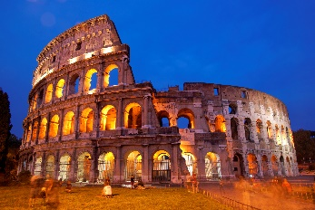 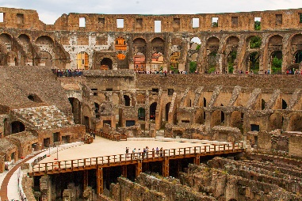 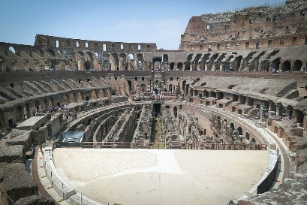

Arena: The arena floor was made of wooden planks covered with sand. Beneath the arena was the hypogeum, a complex network of tunnels and chambers. Due to the destruction caused by the emperor of later generation the arena was destroyed . Excavations in the early 20th century removed much of the remaining debris, exposing the hypogeum to public view.

# Drainage System

The Colosseum's drainage system was a crucial aspect of its design, ensuring the arena remained dry and functional. system consisted of

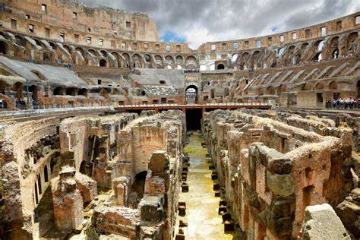Underground Channels: A series of underground sewers, located beneath the arena floor played a central role in the drainage system These channels directed water away from the foundation and arena. They were connected to a central drainage system that led to the main sewer system of Rome, the Cloaca Maxima

# Acoustics

The Colosseum's acoustics were surprisingly effective, considering its size. The design elements contributing to good acoustics: The elliptical shape helped project sound throughout the arena, ensuring that spectators could hear announcements and the sounds of the events clearly. The tiered seating was designed to rise at an angle around the arena. This arrangement helped direct sound waves upwards and outwards.

# Seismic Adaptation

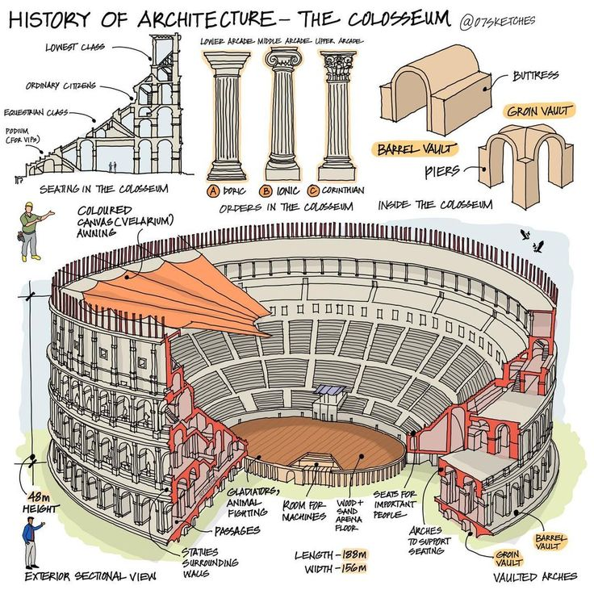Rome is seismically active, and the Colosseum's design includes features to withstand earthquakes:

The combination of arches and vaults distributed the structural load evenly, reducing the risk of collapse in case of seismic activity. :The outer walls were supported by large buttresses that provided additional stability and helped to absorb and dissipate seismic energy.These buttresses acted as counterweights, reducing the risk of outward collapse during an earthquake.

# Conclusion

The Colosseum remains an enduring symbol of Roman ingenuity, with its advanced foundation, innovative architecture, effective drainage system, impressive acoustics, and seismic adaptations. This monumental amphitheater not only hosted spectacular events but also showcased the peak of Roman engineering and architectural mastery.

